Modern Education Society’s
Wadia College of Engineering, Pune

NAME OF STUDENT: | CLASS:
SEMESTER/YEAR: | ROLL NO:
DATE OF PERFORMANCE: | DATE OF SUBMISSION:
EXAMINED BY: | EXPERIMENT NO: MiniProject

ASSIGNMENT – Mini Project
AIM: Mini Project Implementation

TITLE: Online Marriage Registration Portal

OBJECTIVES:

To apply basic programming principles to the construction of websites and effectively manage website projects using available resources.

APPRATUS:

- Ubuntu 24.04 LTS
- XAMPP WEB SERVER
- VS CODE

THEORY:
1. Introduction
The Online Marriage Registration Portal is a web-based application developed to streamline and digitize the conventional marriage registration process. Traditionally, marriage registration involves physical document submission, manual verification, and extended processing times, often resulting in inefficiencies and delays. This project aims to solve these challenges by providing a digital platform using HTML, CSS, JavaScript, PHP, and MySQL, ensuring a secure, transparent, and user-friendly experience for applicants and administrators. The system fosters quicker application handling, minimizes human error, and reduces the environmental impact of paper usage.

2. Objectives
The main objective of this project is to modernize the marriage registration process through a paperless digital system. Specific goals include:
- User Convenience: Enable couples to submit their marriage registration applications remotely with necessary documentation uploads.
- Administrative Efficiency: Allow authorized personnel to verify, approve, or reject applications with appropriate feedback.
- Secure Role-Based Access: Differentiate access rights for users and administrators, ensuring secure and relevant data interaction.
- Data Integrity and Accessibility: Store and manage all records within a secure, relational database for quick retrieval and auditing purposes.

3. System Overview
The system is divided into two primary modules to handle different responsibilities and workflows:
3.1 User Module
- User Registration/Login: Users can sign up or log in using email and password credentials stored in the tbluser table.
- Application Form: Upon login, users fill out a detailed marriage registration form including spouse and witness details.
- Document Upload: Users upload required documents like identity proofs and marriage photos.
- Status Tracking: After submission, users can monitor the progress of their application (Pending, Verified, or Rejected) and view admin feedback.
3.2 Admin Module
- Admin Authentication: Admins log in securely using credentials stored in the tbladmin table.
- Dashboard View: The admin dashboard provides summarized statistics such as total applications, verified records, and rejection rates.
- Application Management: Admins review uploaded documents, validate information, change statuses, and provide user feedback through comments.

4. Technologies Used
- Frontend Technologies:
  - HTML5: For structuring the content.
  - CSS3: For designing responsive and user-friendly layouts.
  - JavaScript: For client-side interactivity and form validation.
- Backend Technologies:
  - PHP: To handle server-side processing, database interactions, session handling, and business logic.
- Database:
  - MySQL: For managing structured data storage, maintaining user profiles, applications, and admin credentials.
- Security:
  - Session Management: To protect sensitive areas and restrict access based on login status.
  - Input Validation: To sanitize inputs and prevent SQL injection or other malicious attacks.
5. Database Design
The database, named marriage, is designed with normalization and relational integrity in mind. The three primary tables include:
- tbluser: Contains user registration information such as name, email, contact, and hashed password.
- tblregistration: Stores detailed application information including husband and wife names, witness details, uploaded documents, and application status. This table links to tbluser via a foreign key user_id.
- tbladmin: Stores administrator login credentials (username and password).
Entity Relationships:
- One-to-Many: A single user can submit multiple applications, but each application belongs to one user.
- Cascading Deletes: When a user account is removed, their associated registrations are also deleted, maintaining database integrity.
6. Security Features
Security is a key component of the system design. The following measures are implemented:
- Client-Side Validation: JavaScript validates form inputs before submission.
- Server-Side Validation: PHP ensures proper formatting and prevents unauthorized input from reaching the database.
- Session Handling: PHP sessions maintain login states and restrict access to unauthorized users or admins.
- File Security: Uploaded files are stored in a protected directory with checks for file type and size to prevent malware uploads.
7. Benefits
The proposed system offers numerous benefits to both users and administrators:
- Efficiency: Automates the registration workflow, significantly reducing processing time.
- Transparency: Users receive real-time updates on their application status and admin feedback.
- Scalability: The portal’s architecture allows for the integration of additional features like payment gateways, OTP verification, or multi-language support.
- Environmental Sustainability: Going paperless reduces the need for physical storage and contributes to green governance initiatives.

PROGRAM CODE:
- index.php
<!DOCTYPE html>
<html>
<head>
<title>Online Marriage Regitration System :: Home Page</title>

<script type="application/x-javascript"> addEventListener("load", function() { setTimeout(hideURLbar, 0); }, false);
function hideURLbar(){ window.scrollTo(0,1); } </script>

<link href="css/style.css" rel="stylesheet" type="text/css" media="all"/>
<link rel="stylesheet" href="css/font-awesome.css">
<link href="//fonts.googleapis.com/css?family=Basic" rel="stylesheet">
<link href="//fonts.googleapis.com/css?family=Titillium+Web" rel="stylesheet">
</head>
<body>
<div class="w3ls-icons">
<ul style="font-size: 30px">
<li><a href="admin/login.php" style="color: #fff;"> Admin</a></li>
<li style="padding-left: 20px"><a href="user/login.php" style="color: #fff;"> User</a></li>
</ul> </div>
<div class="w3ls-head"> <h1>Online Marriage Regitration System</h1></div>
<div class="w3ls-content">
<div class="w3ls-headding">
<h2> <img src="images/5b9d320a2000002d00fdde0f.jpeg"></h2>
<p>We are launching the most awesome site ever. It's gonna be legendary</p>
</div></div>
<footer>Online Marriage Registration System</footer>
</body></html>

PHPMYADMIN
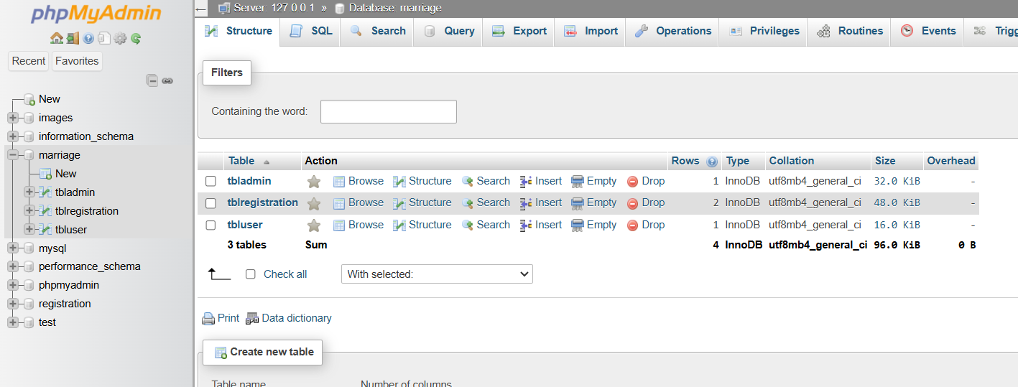

OUTPUTS:
- HomePage
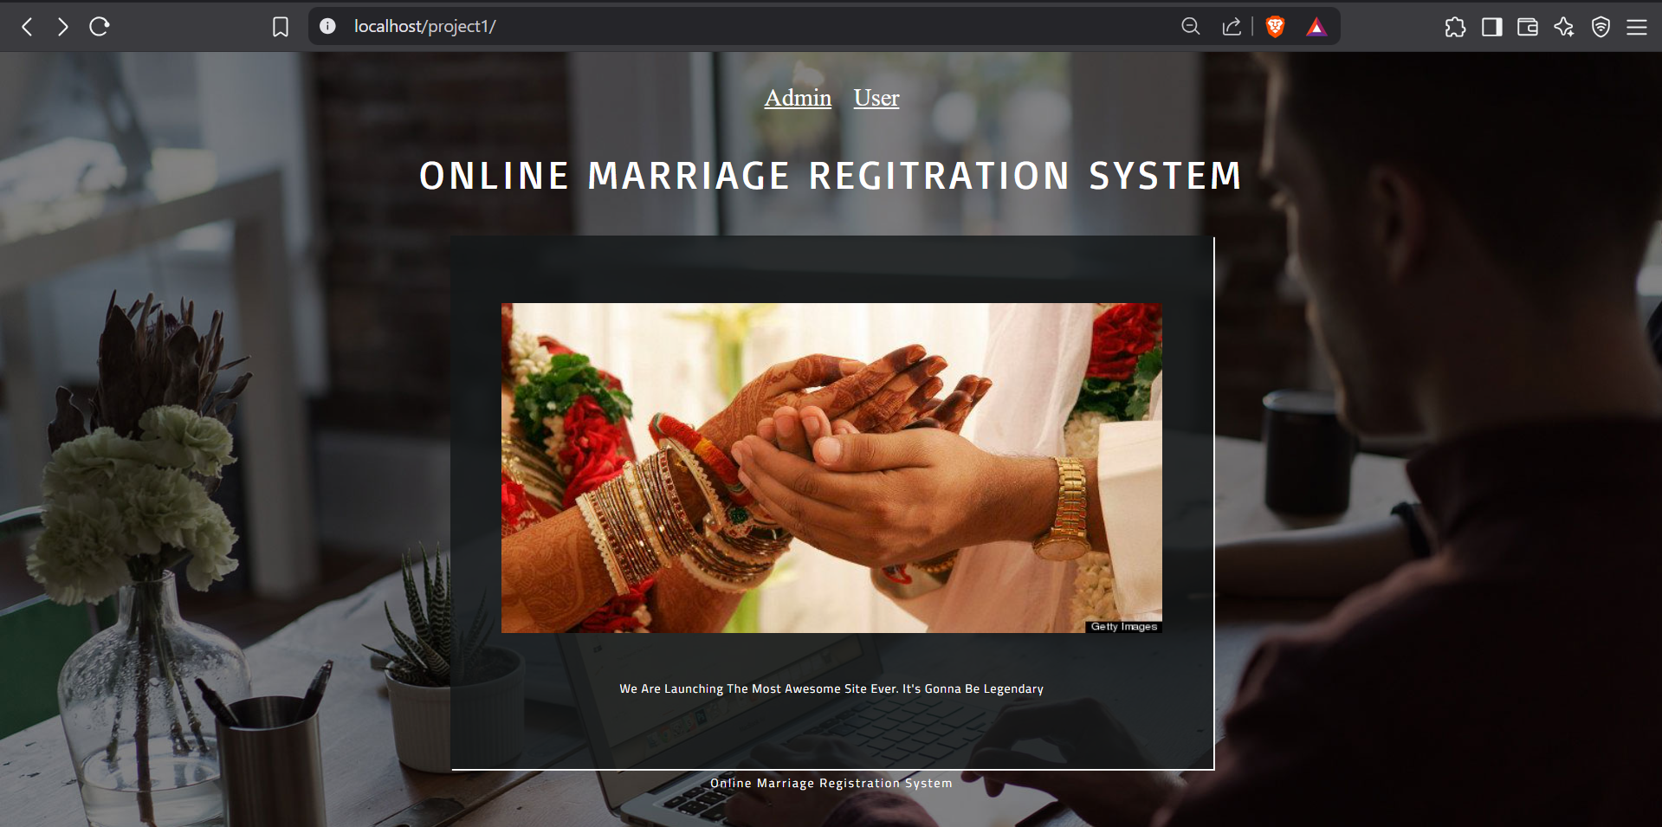
- User Login Page
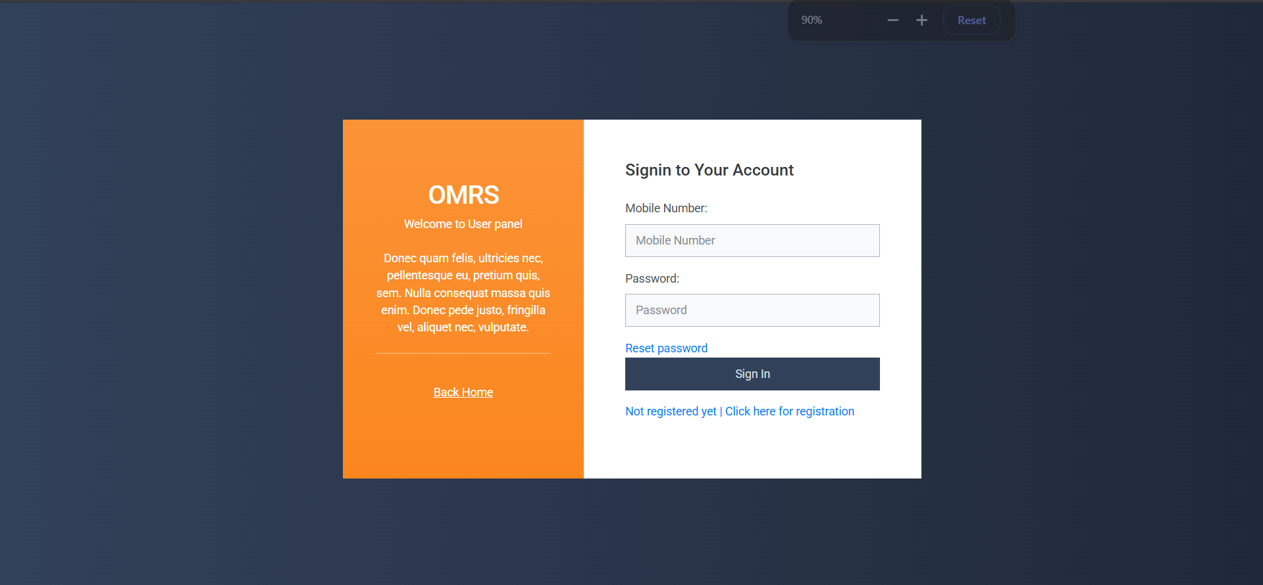
- User Registration Page
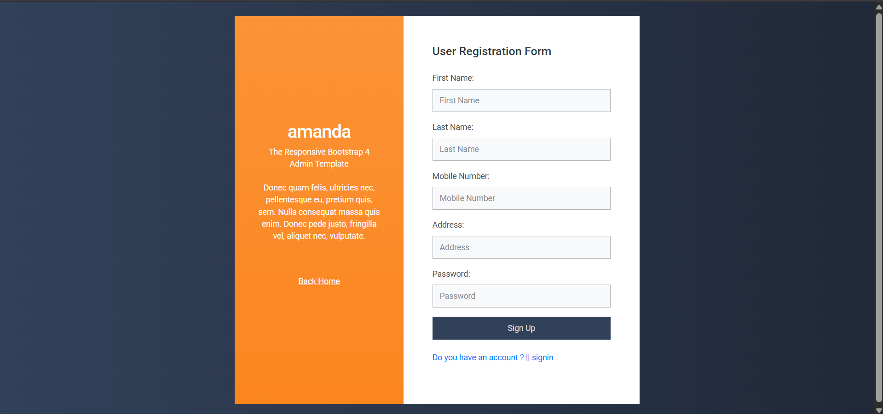
- User Dashboard Page
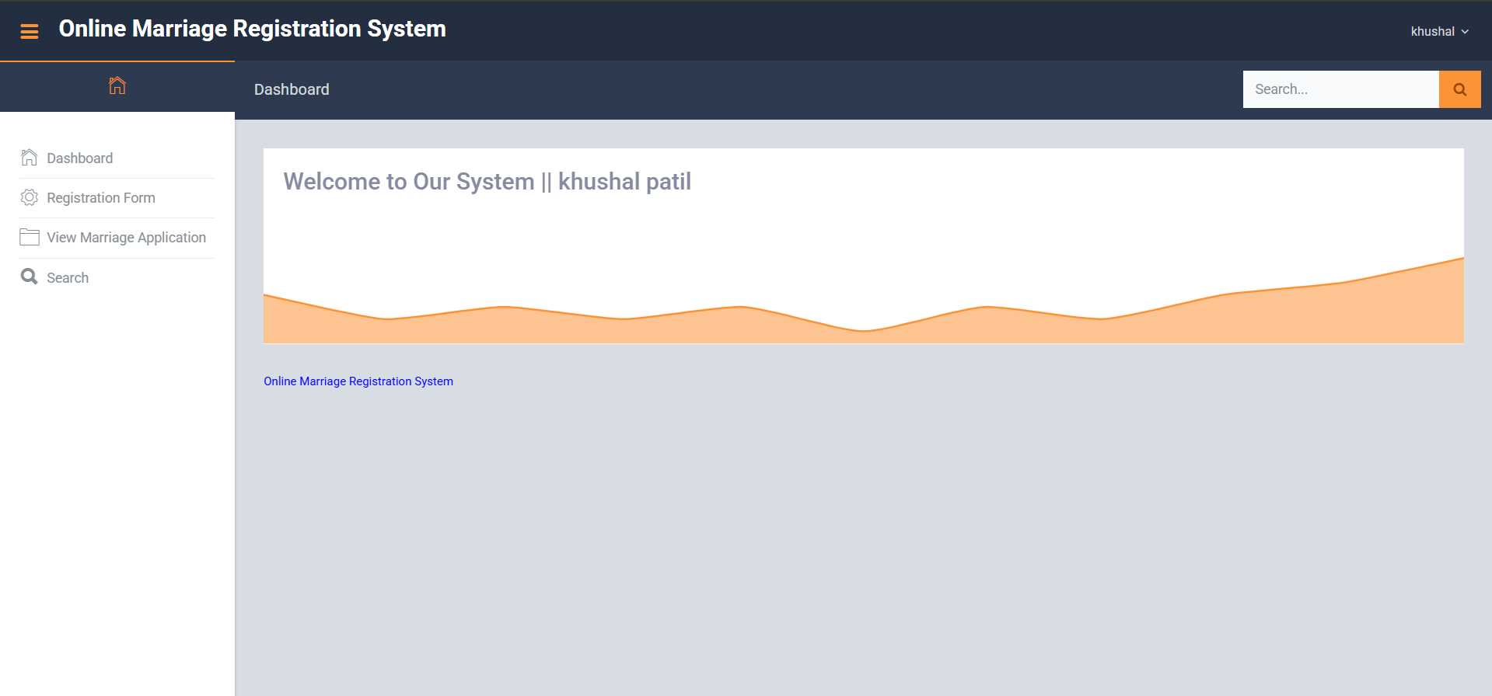

User Registration Form

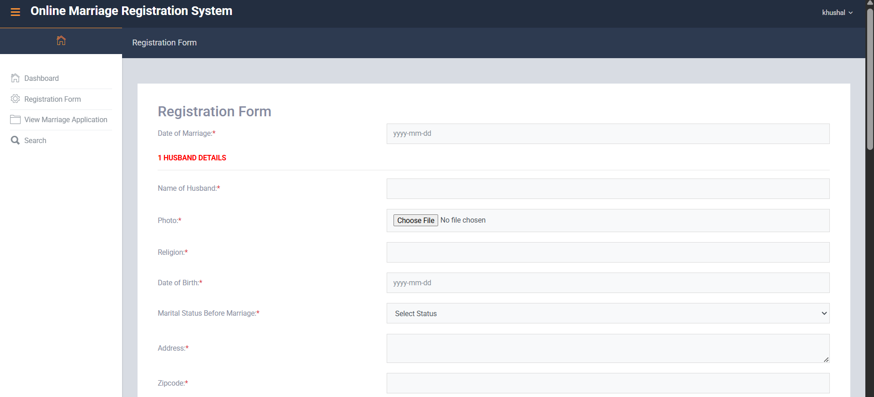
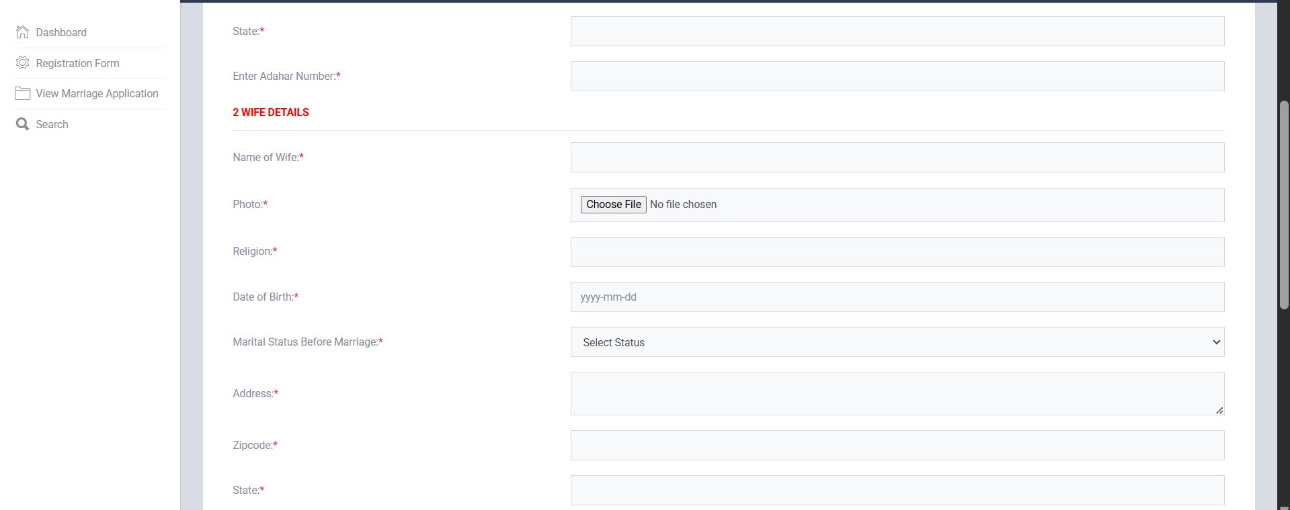
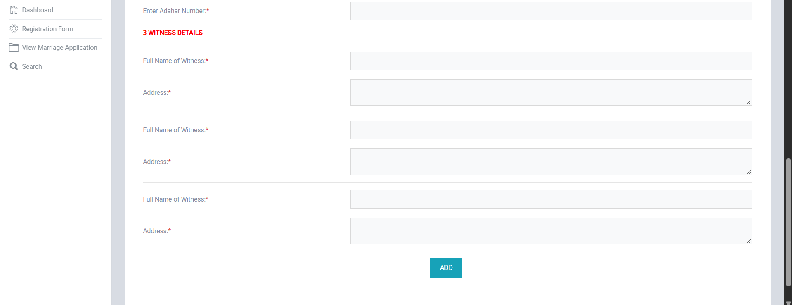

- Admin Login Page
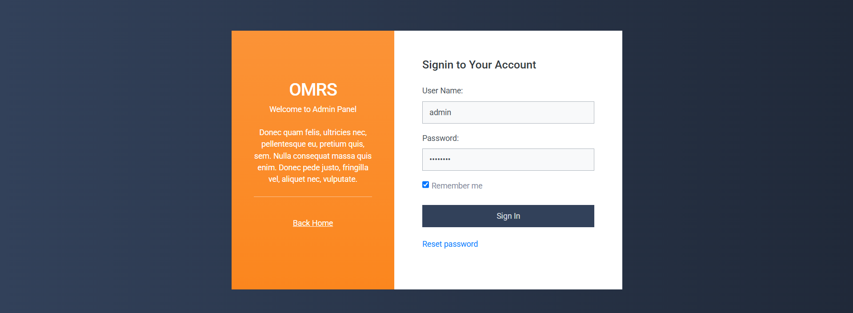

- Admin Dashboard Page

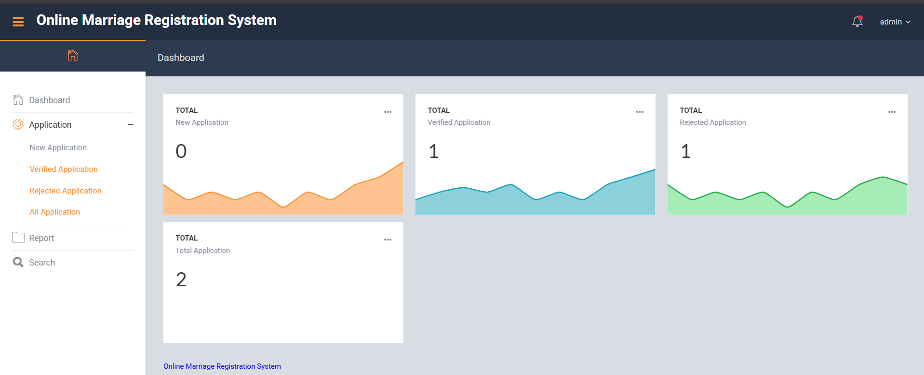

- Admin View Application Page

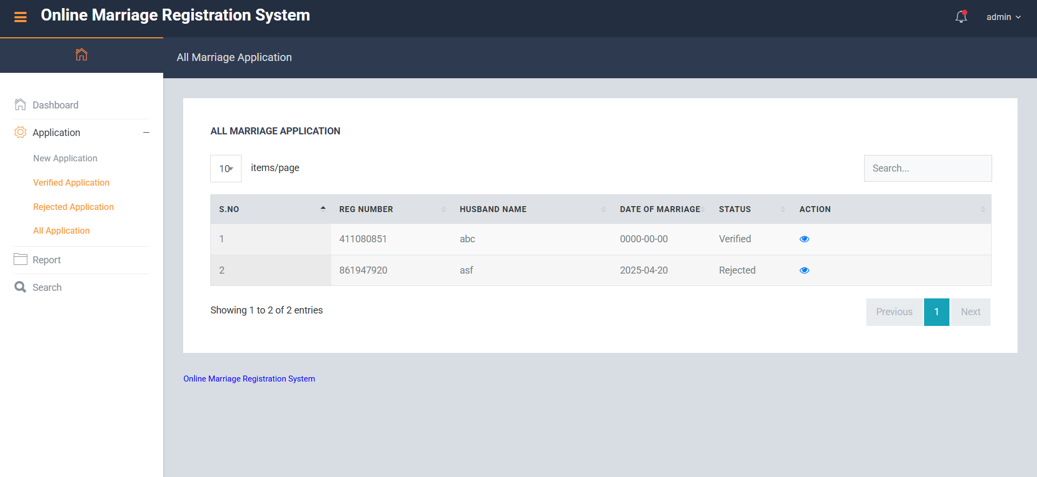
- Admin Application Action Page

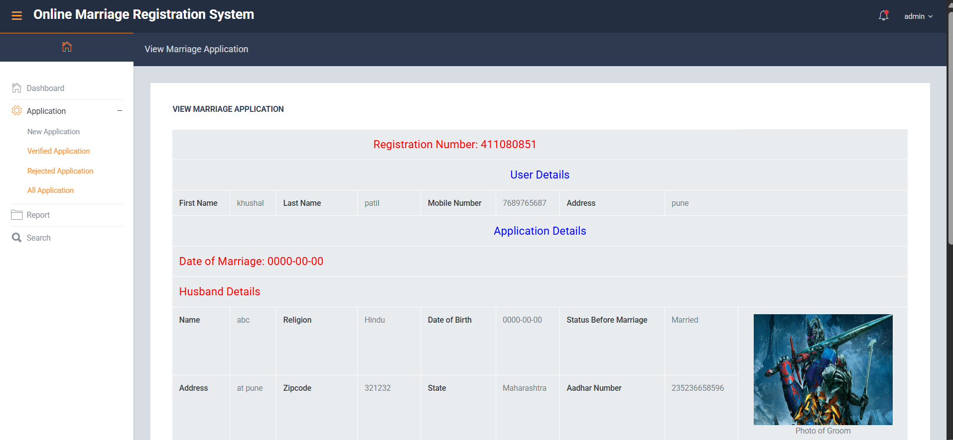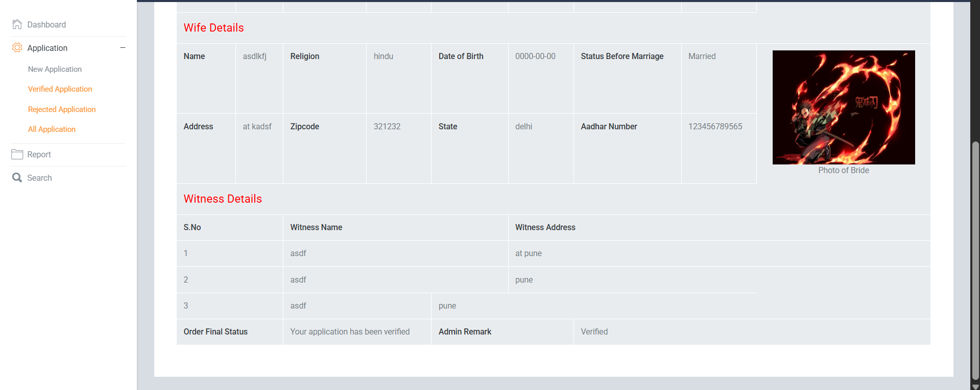

CONCLUSION:

The Online Marriage Registration Portal is a complete web solution to simplify and modernize the marriage registration process. By offering a secure, accessible, and efficient platform for both users and administrators, the system ensures convenience, reduces the workload of administrative staff, and promotes transparency and digitization. This project also demonstrates a strong understanding of full-stack web development, database design, and user experience principles.

